Main Benefits Of Watching Imagine Movie Theatre
Written By: Group5

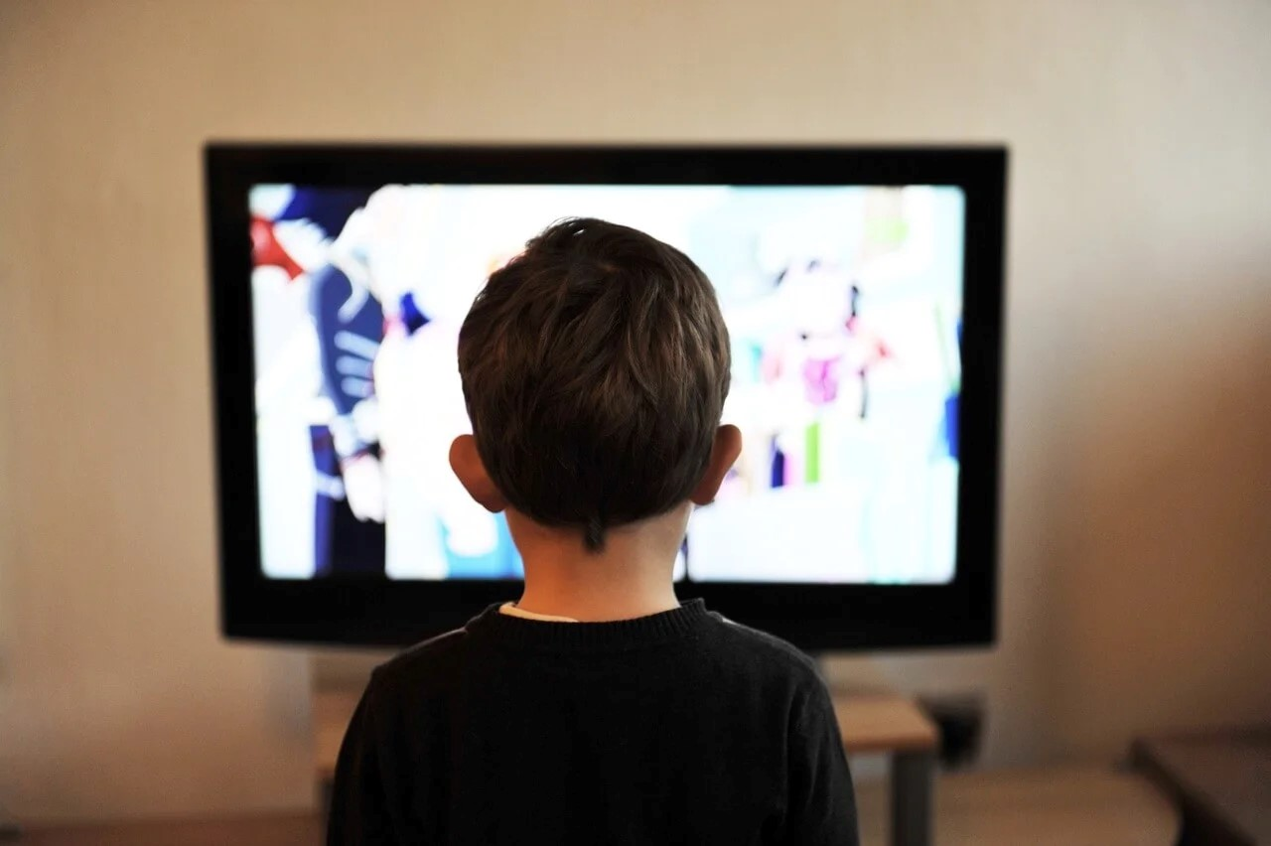
We all like viewing movies on television or the internet, almost without exception. Nonetheless, one of the most common methods of watching movies is to connect to the internet and browse through websites that offer movies for free. The introduction of social networking websites such as YouTube has ushered in a new era in this eld. You can now view most of your favorite movies on YouTube, which has become increasingly popular. This article will discuss the advantages of viewing your favorite movies and television shows on the internet in greater detail.

Accessibility to a large number of lms
If you go about on the internet, you will nd hundreds of websites that allow you to download your favorite things for free. There is good news that you can access hundreds of thousands of movies and view them entirely for free. In addition, you can download them if you choose. You will be able to watch them on your mobile devices as a result.


By watching movies on the internet, you may save a lot of money on your entertainment expenses. Traditionally, you would have to purchase a DVD containing all of your desired movies, with each title costing you more money. The cost of this may be too expensive for those with low nancial resources.
Alternatively, if you visit streaming websites, you will only be required to pay a monthly or annual membership price, depending on your preference. Once you have paid the cost, you will be able to watch any of the available titles on their website at your leisure. If you are seeking an affordable choice, you might want to look into these websites.

Quality of the Movie
If you’re seeking high-quality movies to watch online, YouTube and other streaming services are excellent resources. The good news is that you don’t have to download these movies because they can be accessed on streaming services, which eliminates the need to download them. Downloading a movie might take up a signi cant amount of space on your computer’s hard disk. Furthermore, you may not have a lot of storage space.

Saves time.
It is not necessary to download the movies to watch them. It may take many hours for a lm to download onto your Pc. It is encouraged that you view them online if you don’t want to waste so much time. The moment you press the play button, the movie will start to play. Furthermore, you have the option of rewinding or fast-forwarding the video to suit your preferences.

Conclusion
What’s excellent about viewing movies online is that you have complete exibility to select whatever lm you want to see. There are no restrictions on when or where you can participate. Furthermore, you will not have to spend any money because you will not be required to attend a movie.
Keeping the long tale short, these are just a few of the advantages of viewing your favourite movies on the internet.

Search


